***St. John Chrysostom*** 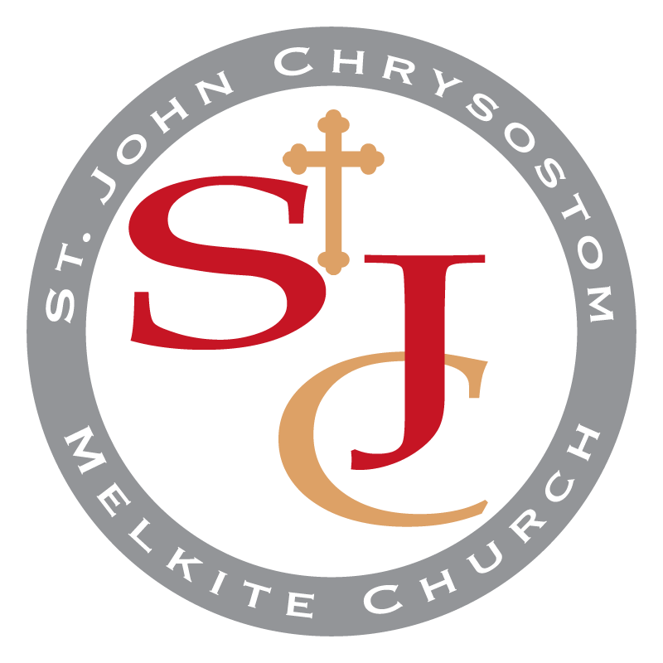

***Melkite Catholic Church***

**A Parish Community of the Eparchy of Newton**

**Bulletin for Sunday, December 4, 2022**

10th Sunday After the Holy Cross – Tone: 1 – Orthros Gospel: Luke 24:1-12 (4)  
Healing a Woman on the Sabbath - Holy Great Martyr Barbara and of our Holy Father John the Damascene

الاحد، 4 كانون الأول 2022

الاحد العاشر بعد الصليب - تذكار القديسة العظيمة في الشهيدات بربارة

**1428 Ponce de Leon Ave NE, Atlanta, Georgia 30307, Office: (404) 373-9522, Fax: (404) 373-9755, Email:** [contact@stjohnmelkite.org](mailto:contact@stjohnmelkite.org)

**Web:** [stjohnmelkite.org](http://www.stjohnmelkite.org)  **•** **FB:** [facebook.com/StJohnMelkite](http://www.facebook.com/StJohnMelkite) **•** **YouTube:** [www.youtube.com/@StJohnMelkite](http://www.youtube.com/@stjohnmelkite)

Rev. Deacon Sami Jajeh & Rev. Deacon Elie Hanna, Parish Administrators

Rt. Rev. Archimandrite John Azar, Pastor Emeritus

Rev. George Gage, Celebrant and Rev. Dr. Thomas Flynn, Retired

Parish Advisory Council Chairperson - Deacon Elie Hanna - [deaconelie@stjohnmelkite.org](mailto:deaconelie@stjohnmelkite.org)

Finance Council Chairperson - Deacon Sami Jajeh - [deaconsami@stjohnmelkite.org](mailto:deaconsami@stjohnmelkite.org)

Cultural Center Manager - Jerome Hagley - [jerome.hagley@gmail.com](mailto:jerome.hagley@gmail.com)

**10:00 AM – ORTHROS 10:30 AM – DIVINE LITURGY**

**Followed by Coffee Hour Fellowship in the Cultural Center.**

**Parish Church Year Theme**

(Liturgical Year – began Sept. 1, 2022 – ends Aug. 31, 2023):

*"The God of heaven will give us success. We His servants will start rebuilding." (Nehemiah 2:20)  
إنَّ إلهَ السَّماء يُعطينا النجاح ونحنُ عَبيدهُ نَقومُ ونَبْني." (نحميا ٢٠:٢)”*

**---------- A WARM WELCOME TO ALL ----------**

**HAPPY TO HAVE VISITORS WITH US!** Please sign our Visitor’s Guest Book in the narthex (entrance) of the church. If interested in receiving news, make sure we have an email address. And join us in the Cultural Center behind the Church to introduce yourself.

**INTERESTED-IN-BECOMING-CATECHUMENS/PARISHIONERS?** Please send email to [contact@stjohnmelkite.org](mailto:contact@stjohnmelkite.org) or leave your contact information in the guest book in Narthex. We ask for an ongoing attendance period before requesting to be a member.

**---------- PARISH LIFE UPDATE ----------**

**NATIVITY FAST:** If you have not been following the Traditional Fast, know that the Melkite form of the Fasting period begins on Dec. 10th.**Volunteers needed Sunday, Dec. 4th** after Liturgy to help change colors to somber colors for the Nativity Fast.

**CHURCH AND CULTURAL CENTER DECORATIONS:** Thank you to all those who helped to decorate the church and hall for the Nativity season! **Volunteers will be needed to finish the decorations by adding color on the Sunday of December 18th in preparation for the Nativity Divine Liturgy on Dec. 25**

**ADULT EDUCATION PROGRAM:** The newly formed Adult Education program will start on **Sunday, December 4th after Divine Liturgy in the Cultural Center**. The first topic is in Scripture Studies (Faith: The Foundation). The second program will be on Thursday, December 15th at 7:30pm via Zoom in Scripture Studies (Work of Righteousness).

**UPCOMING CHRISTMAS program:** Visit by St. Nicholas, Children Christmas Program and the Bake Sale will be held **Sunday, Dec. 11th after liturgy in the Cultural Center**. Please come for this special celebration of the Feast of St. Nicholas.

**---------- SUNDAY DIVINE LITURGY ----------**

As a spiritual family, we encounter heaven on earth through the Divine Liturgy - the Lord’s Day (*Kyriake* inGreek) as a priority for all families; making up of any missed financial support; and a resolve for all to let us live a renewed life in Christ through Church!

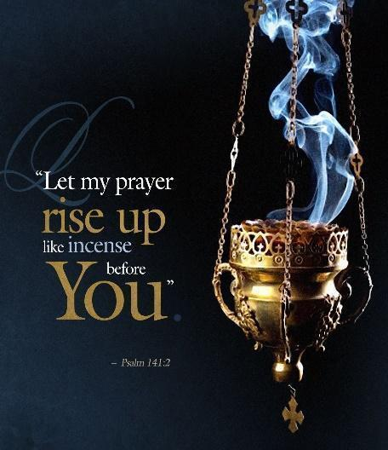**COMMUNION:** If you are unable to make Divine Liturgy on Sunday due to health reasons, and you would like to receive the Holy Eucharist, please e-mail [contact@stjohnmelkite.org](mailto:contact@stjohnmelkite.org) by Saturday so that a clergy member may visit you with Communion. As a reminder, Church school begins immediately after communion, so on school days, note that the teachers and students will exit into the pews for communion first. Thanks for your help.

**THIS WEEKEND, SUN., NOV 27 LITURGY COMMEMORATIONS**

**REPOSE IN THE HEAVENLY KINGDOM**

+Michael Shikany, Requested by Dr. & Mrs. Shajih Muhanna

+Mary Baroody, Requested by St. John Parish Community

+Nader Farhat, Requested by Jerome and Susie Hagley

**HEALTH & SALVATIO****N**

Fr. Tom Flynn, Requested by St. John Parish Community

Danny Hutchinson, Requested by Dcn. Elie Hanna and Family

Tammie Pogue, Requested by Dcn. Sami Jajeh and Family

Those in our Prayer Line, Requested by St. John Parish Community

Peace in the World, especially in the U.S., Middle East, Holy Land, Ukraine

**LITURGY INFORMATION**

**Altar Servers:** Contact Deacon Elie if interested. Servers’robes are blessed for Orthros (9:50) and Divine Liturgy (10:15). Be early!

**Masstimes.org:** If traveling, consider researching schedules of weekend liturgies, (Melkite, Byzantine Catholic or Roman Catholic). If there is no Catholic Church in the area, you may attend an Orthodox church when on vacation.

**---------- UPCOMING AND IMPORTANT EVENTS ----------**

**SUN, DEC 4 – FEAST OF ST. BARBARA:** The Feast Day for St. Barbara (died c. 200 CE), legendary virgin martyr of the early church.

**SUN, DEC 4 – ADULT EDUCATION PROGRAM:** Join us in the cultural center for a program on the Sacred Scriptures.

**SUN, DEC 9 – FEAST OF THE MATERNITY OF ANNA AND CONCEPTION OF THE MOST HOLY THEOTOKOS**: According to the ancient tradition of the Church, since Saint Anna, the Ancestor of God, was barren, she and her husband Joachim remained without children until old age. Therefore, sorrowing over their childlessness, they besought God with a promise that, if He were to grant them the fruit of the womb, they would offer their offspring to Him as a gift. And God, hearkening to their supplication, informed them through an Angel concerning the birth of the Virgin.

**SUN, DEC 11 – CELEBRATION OF FEAST OF ST. NICHOLAS:** The Feast of St. Nicholas of Myra (Dec 6th), also known as Nicholas of Bari, was an early Christian bishop of Greek descent from the maritime city of Myra in Asia Minor during the time of the Roman Empire. Because of the many miracles attributed to his intercession, he is also known as Nicholas the Wonderworker.

**SAT, DEC 24 and SUN, DEC 25 – CELEBRATION OF THE FEAST OF NATIVITY:** The liturgical calendar for the Feast of Nativity is still being considered. This year, it falls on a Sunday, so the Divine Liturgy for the Feast of Nativity and Sunday are one and the same.

**SUN, JAN 1 – NEW YEAR/FEAST OF CIRCUMCISION OF CHRIST:** Since New Year falls on a Sunday, the Divine Liturgy for the New Year will be the same Divine Liturgy for this Sunday. There is no better way to start a new year than to put God first in worship, praise, and hymns during the Divine Liturgy.

**SUN, JAN 8 – CELEBRATION OF THE FEAST OF THE THEOPHANY** (Actual Feast date is January 6th)

**SUN, JAN 15 – MEMORIAL SERVICE AND MERCY MEAL:** +Michael Shikany

**SUN, JAN 22 – GENERAL ASSEMBLY:** A parish general assembly will occur at the end of Divine Liturgy in the Cultural Center.

**---------- ARE WE PREPARING? ----------**

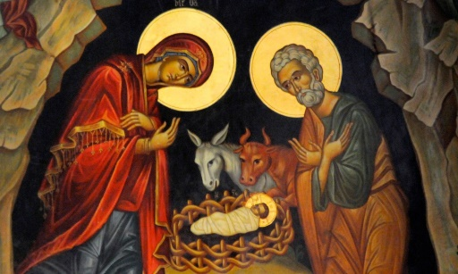Christmas is a time of joy, wonder, and excitement. It celebrates the birth of our Lord and Savior Jesus Christ. The Feast of Nativity celebrates the Incarnation of the only-begotten Son of God. As such, we should prepare ourselves accordingly, so we can welcome Him with pure hearts and contrite spirits. The Kondakion of the Preparation of the Nativity of our Lord reminds us that: ***Today the Virgin is on her way to the cave where she will give birth to the Eternal Word of God in an ineffable manner. Rejoice therefore, O Universe, when you hear this news and glorify with the angels and the shepherds Him Who shall appear as a new Child being God from all eternity.***

**---------- STEWARDSHIP (*AL WAQF*) IS A WAY OF LIFE ----------**

**This is our being entrusted by God with the gifts of the earth and of our church. We are all stewards: earthly caretakers and managers for the Lord. Our return of Time, Talent, and Treasure to Him. It is a way of life!**

**TIME AND TALENT: Volunteers Needed** to help lead various ministries. **Liturgical Participation:** Please consider joining the Choir, being a reader (see Eric Hansen), becoming an usher (see Joe M. or Jerome H.) or an altar server (contact Dcn. Elie).

[](https://shop-stjc-mcc.square.site/)

**TREASURE:** [CLICK HERE TO DONATE NOW](https://shop-stjc-mcc.square.site/), or scan QR Code or send an email to [contact@stjohnmelkite.org](mailto:contact@stjohnmelkite.org) to set up ACH donations. All checks should be made to “St. John Chrysostom Melkite Church” except for diocesan collections, which should be made out to “Diocese of Newton.” We receive Zelle donations at [donate@stjohnmelkite.org](mailto:donate@stjohnmelkite.org). Identify donation purpose of donations in memo field.

**MONTHLY FINANCIALS (NOV 2022):** Total Income $12,725, including Ordinary Collections: $10,189 with Total Expenditures of $22,542, including $9,798 building repairs and maintenance (including new HVAC), leaving a Net Difference **(-$9,817).**

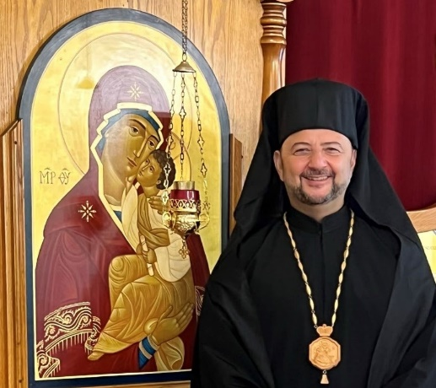**2022 BISHOP’S APPEAL** Offer your gratitude to God by giving a generous gift to the 2022 Melkite Catholic Eparchy of Newton’s Bishop’s Appeal today. Thank you for your continued generosity to our parish and our Melkite Catholic Eparchy. The mailing from the diocese will be sent shortly to you. In the meantime, if you would like to give now, you may do so, by making your check payable to Eparchy of Newton, placing “**Bishop Appeal 2022 – St. John Chrysostom, Atlanta**” in the memo field and sending it to:

Eparchy of Newton

Attn: Bishop Appeal

3 VFW Pkwy

West Roxbury, MA 02132

**WHAT ABOUT TRADITION?** To be good stewards of tradition, we must not only learn it and grow spiritually but share it - perhaps by inviting a friend to the Divine Liturgy or praying for others, including those in our Prayer Line below.

**---------- PRAYER IS A WAY OF LIFE ----------**

**COMMEMORATIONS:** GIVE THE GIFT OF PRAYER! Send a commemoration request for a family member, friend, colleague or more such as: (a) Repose of their soul, (b) health and wellness, (c) commemorate a special event in their life. Send your requests to contact@sjohnmelkite.org by Thursday.

**Please keep in your prayers…**

**Evelyn Whalen Souren Palanjian**

**Vic Maloof Fr. Tom Flynn**

**Albert Mishu Judy Nassar**

**Nadir Haddadin Jean Pierre Garcia (Jay)**

**Shikany Family Baroody Family**

**Those affected by the virus Victims of natural disasters**

**Those approaching matrimony The Wandering Sheep of this parish**

***May the Divine Physician of our souls and bodies extend   
His healing hand over His servants and handmaids****.*

For those in need of prayer and to keep us up to date on everyone’s condition, please share at contact@stjohnmelkite.org.

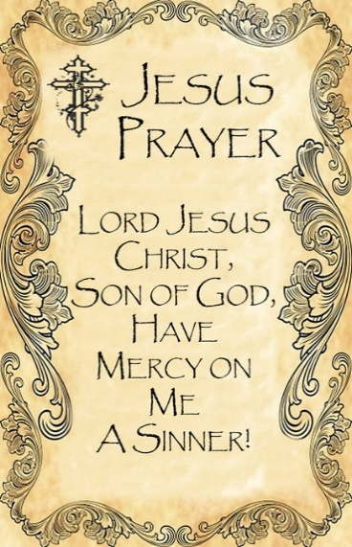



**December Birthdays**

**Name Days, Anniversaries**

Note: The information below is from our Parishioner database. We apologize IN ADVANCE for anyone who is missing or any information which is mistaken. Please send corrections to contact@stjohnmelkite.org so we

**Name Days for St. Barbara, St. Nicholas, St. Spiridon,**

Nicholas Curry

**Birthdays:**

Michael Madanat Tyra Nuar

Salma Layous Nora Mishu

Rouviette Hanna

Suleiman (John) Madanat

**Anniversary:**

Evelyn Whalen Craig & Melinda Ajmo

**--- The Great Martyr St Barbara---**

St Barbara is first mentioned in a seventh-century Roman Martyrology, some 350 years after her death. The sources of what has been passed down about her were collected by St Simeon Metaphrastes (“the Translator”) in his tenth-century lives of the saints, the Menologion.

Middle Eastern sources record that Barbara was from Heliopolis (Baalbek in present-day Lebanon). Some sources describe her as a native of Heliopolis in Egypt or even of Nicomedia (in Turkey today). All the stories of this martyr say that she was the daughter of a rich pagan named Dioscoros who, after his wife’s death, kept Barbara locked in a tower to keep her from the eyes of strangers.

After a certain time Dioscoros relented and allowed his daughter a measure of freedom. She became acquainted with the Gospel through some young Christian women who befriended her and through a priest fleeing persecution in Alexandria, who ultimately baptized her.

Dioscoros had commissioned the construction of a bath house on his estate. In his absence Barbara had altered the plans to include a third window, to represent the Trinity. When Dioscoros learned the reason for her actions he flew at her in a rage. She escaped and fled from him, using a number of disguises. She was eventually captured and severely beaten.

The last great persecution of Christians in the Roman Empire was in full swing. When Barbara would not renounce her faith, Dioscoros handed her over to the prefect of the city, Martian, who subjected her to public humiliation and torture. Juliana, a Christian woman in the crowd reproached Martian for his cruelty. In return he condemned Juliana to die with Barbara. Both were beheaded, Barbara (it is said) by her own father. A pious man named Galentian recovered the bodies of Barbara and Juliana, buried their remains and, when the persecutions ended, erected a shrine in their memory.

In the sixth century, relics of St Barbara were brought to Constantinople. Six hundred years later a portion of them was brought to Kiev by Barbara, the daughter of the Byzantine emperor, when she married Michael, the Grand Prince of Kiev. Around the same time, the Coptic church of St Cyrus in Old Cairo was rebuilt as the Church of St Barbara to house relics of this saint. She is venerated in all the Churches of East and West. Because of the lack of contemporary witnesses to her struggle, the Roman Church removed her name from their universal calendar. She is still venerated in local Western Churches, particularly in Europe.

In the Middle East, her feast is observed by the preparation of sweets, including the “Barbara.” This is the traditional boiled wheat dish made for memorials of a saint or of the deceased. In this case it is sweetened with pomegranate seeds, raisins, anise and sugar. It is frequently brought to homes by children singing a traditional carol about this saint. They are often costumed to recall the disguises which St Barbara used to elude her father.

**---------- MINISTRY LEADERS ---------**

**Adult Education** – Greg Pharo

**Altar Servers** – Deacon Elie Hanna

**Choir** – Sohel Elias

**Children Education** – Viola Ghawi, Tyra Nuar

**Cultural Center Rental** – Jerome Hagley

**Friday Fellowship** – Rita Karroum, Vera Madanat

**Gift Shop** – Joseph Manguno, Patty Pharo

**Good Samaritan Society** – Suely Elias, Marie Hansen

**Ladies Society** – Susie Hagley, Lina Muhanna (co-presidents)

**Men’s Club, Publican Society** – OPEN

**Readers** – Eric Hansen

**Sunshine Committee** – Matilda Ghawi

**Ushers** – Jerome Hagley, Robert Ghawi, Joseph Manguno

**--- VICTIM ASSISTANCE COORDINATOR ---**

To report sexual abuse by clergy, parish personnel or volunteers of the Eparchy of Newton, please call the Victim Assistance Coordinator at 1-800-479-5910.